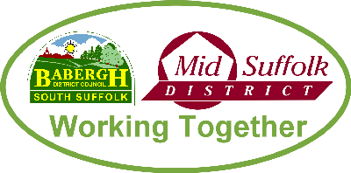
Neighbourhood CIL Expenditure Report

Town or Parish Council – NEDGING WITH NAUGHTON
1 April 2024 to 31 March2025

A | Total CIL income balance carried over from previous year | £6,008.00
B | Total CIL income received in reporting year (receipts received in April and October) | £0
C | Total CIL spent within reporting year (expenditure, net amount if VAT recoverable) | £2,201.18
D | Total CIL retained at year end (A+B-C) | £3,806.82

Neighbourhood CIL Expenditure – Details of Spent Funds
Items to which CIL funds have been spent: | (Net amount if VAT recoverable)
SCC Street Furniture Licence for Village Welcome Gate) | £160.00
Installation of 4 Village Welcome Signs (Brooks & Wood) | £2,000.00
Address Lables (Neighbourhood Plan Questionnaire) | £41.18
Total spent | £2,201.18
Neighbourhood CIL – Details of Allocated Funds (not yet spent)
Items to which CIL funds have been allocated but not yet spent: | (Net amount if VAT recoverable)
Total Allocated | £

Has the expenditure report been uploaded onto the Parish’s website: (Y/N)
To be uploaded after signatures inserted at next meeting on 13th May 2025

This form needs to be signed by two representatives of the Parish/Town Council (electronic signatures are not acceptable)

Signed: ……………………………………….. Position: ………………………………

Verified: …………………………………….. Position: ………………………………

Please scan and email this form to the following email address
infrastructure@baberghmidsuffolk.gov.uk

